Hillside Lincoln F10 USA2230 Dan Nyberg
Valley of the Mist Farm
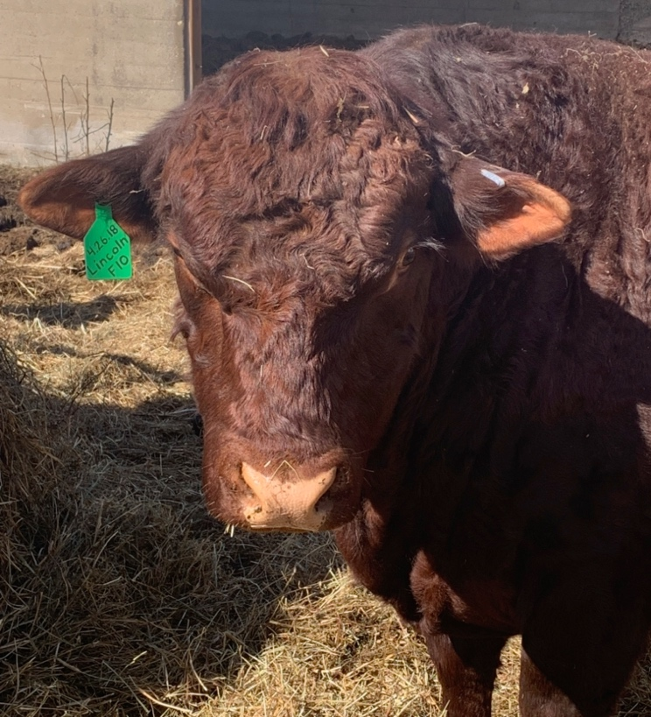
DoB April 26, 2018 4 yr. old bull 7398 Kishwaukee Rd. Stillman Valley, IL 61084 (815) 218-4442

$4,500 sale price fall 2022

Weight on 9.19.21 1,460

Height at shoulder 52”

Frame Score 3

Homozygous polled

Purchased from Daniel Marquardt at Hillside Pastures on 6.10.20

Out of Brookviews Z61

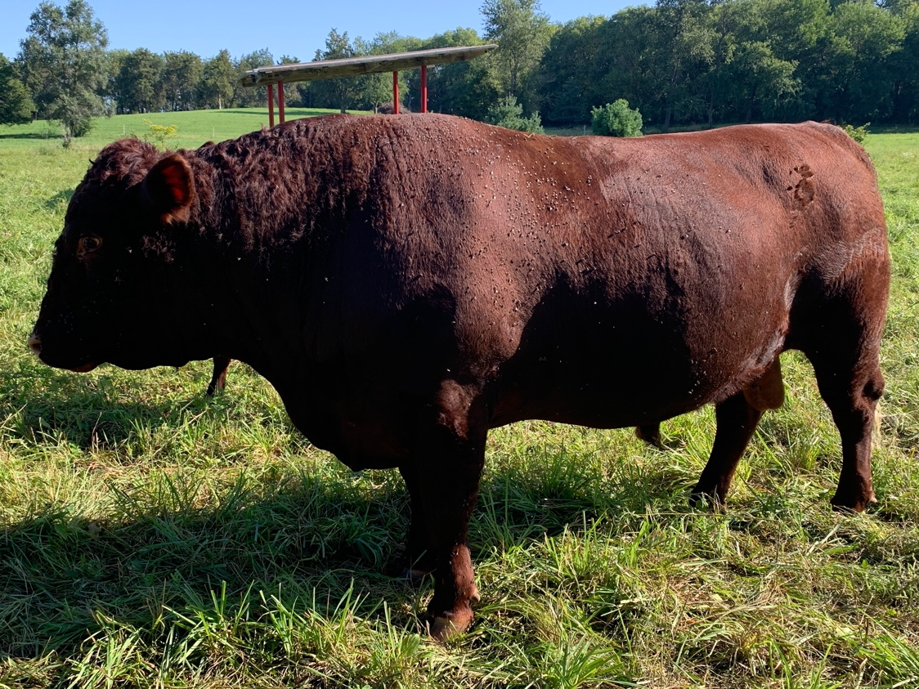
Photo March 2, 2022

Photo Aug. 30, 2022

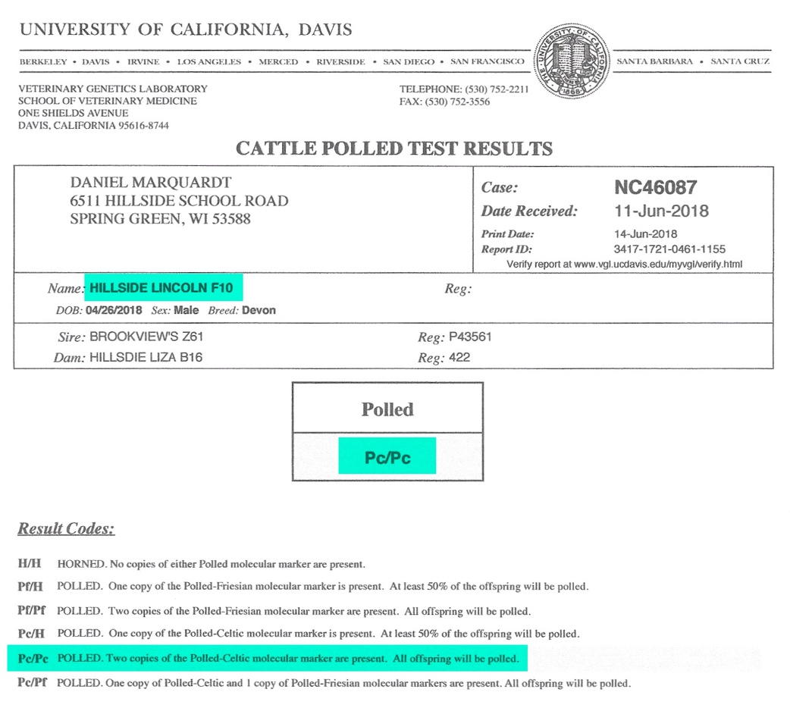

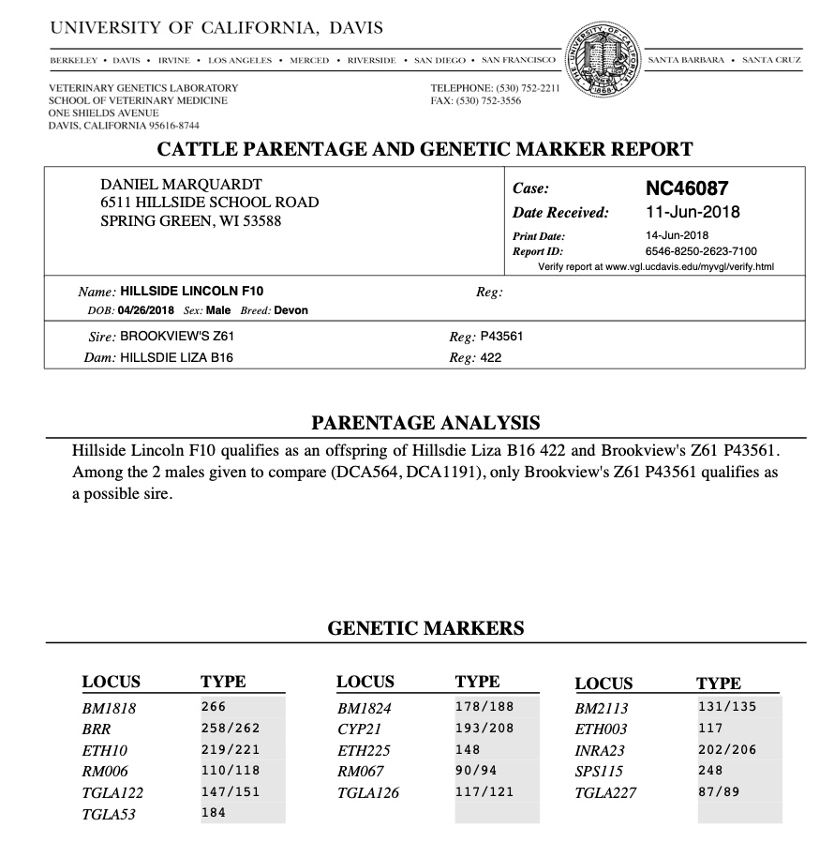

2021 Calves: 4 bulls / 3 heifers 80 lb ave. birth weight 17 day window

2022 Calves: 1 bull / 4 heifers 84 lb ave. birth weight 30 day window

F10 Hillside Lincoln
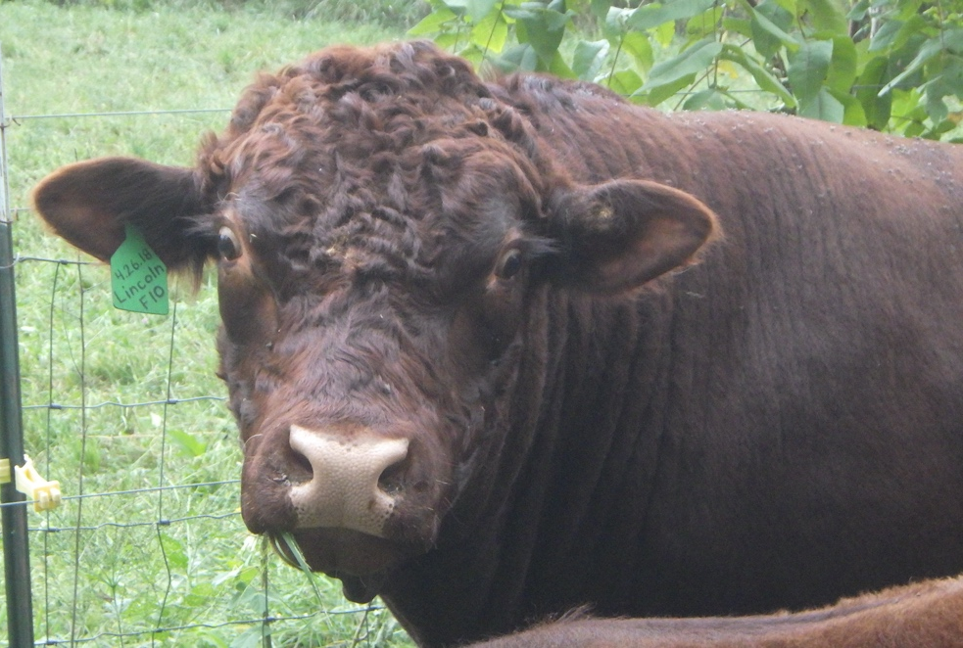

Photo 9.17.21

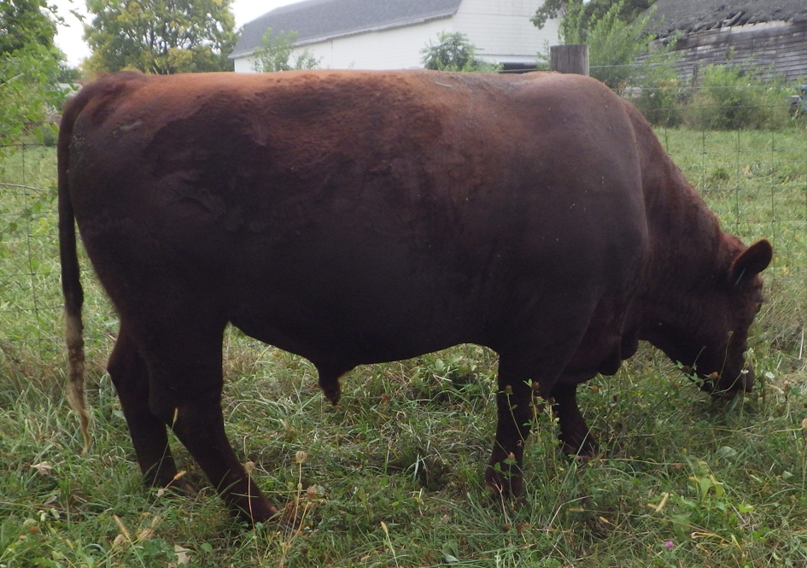

Photo 9.17.21

I have been working on downsizing my cows and am finally seeing some good results. My cows are running in the 1,100 – 1,200 lbs range as mature cows after using the smaller frame score bulls. Previous to Lincoln I owned Franklin who was also a Frame Score 3 bull – similar size.

I am keeping a bull calf of Lincoln’s born in 2021 – J1 Jackson – born to a 13 year old cow who has produced a good healthy calf every year. J1 Jackson is also homozygous polled – a priority of mine to eliminate dealing with dehorning.

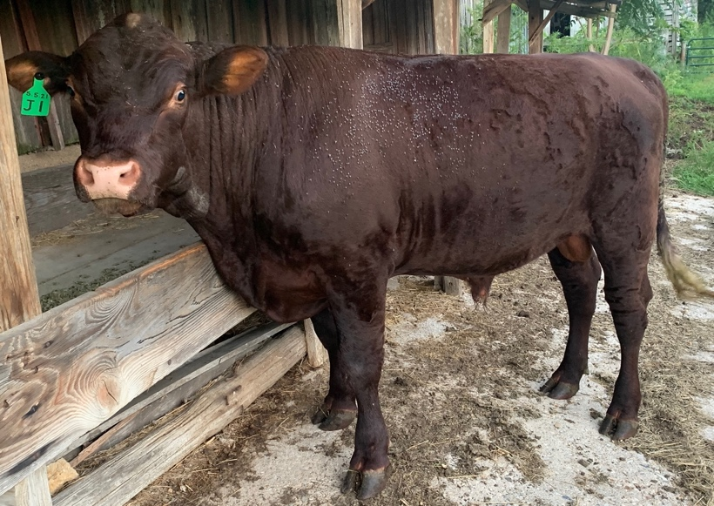
VOM Jackson
dob 5.5.21

Photo on Aug. 30, 2022

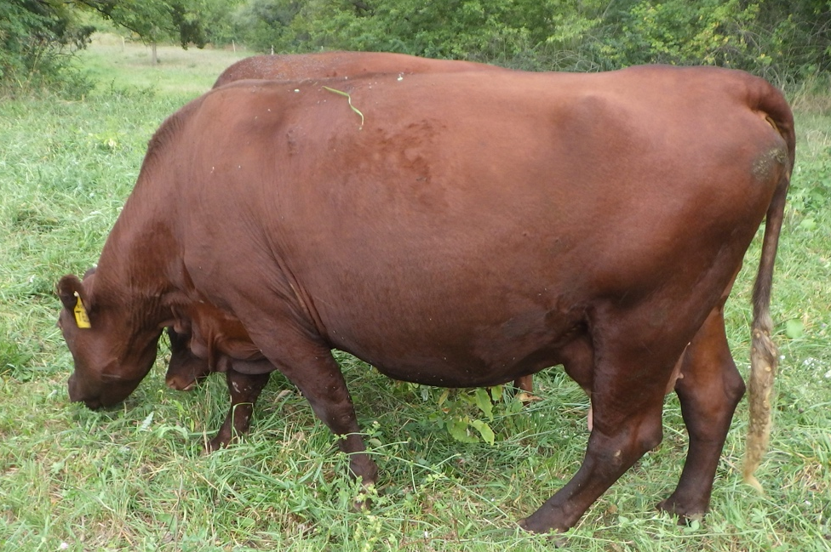

T62 Homestead Ashley

Dob 6.11.08

Jackson’s dam

